select contr_emprst_fss.num_sqncl_cempf Contrato, 'quitado' situacao, sum(lancto_emprest_fss.vlr_pagto_lcemp) vlr_Pagamento, 0.00 vlr_estorno from empregado, participante_fss, contr_emprst_fss, lancto_emprest_fss where ( empregado.cod_emprs = participante_fss.cod_emprs ) and ( empregado.num_rgtro_emprg = participante_fss.num_rgtro_emprg ) and ( participante_fss.num_matr_partf = contr_emprst_fss.num_matr_partf ) and ( contr_emprst_fss.num_sqncl_cempf = lancto_emprest_fss.num_sqncl_cempf ) and ( contr_emprst_fss.cod_tpepf in ( 1, 2, 3, 4, 5, 6, 7, 8 )) and ( contr_emprst_fss.cod_situa_cempf <> 'C' ) and ( contr_emprst_fss.dat_incl_cempf between {ts '2012-01-01 00:00:00.000'} and {ts '2012-01-31 00:00:00.000'}) and ( contr_emprst_fss.dat_quitc_cempf between {ts '2012-01-01 00:00:00.000'} and {ts '2012-01-31 00:00:00.000'}) and ( lancto_emprest_fss.cod_tipo_lcemp = 'Q') and ( 0 = 0 ) AND ( contr_emprst_fss.num_plbnf in ( 6 )) AND ( lancto_emprest_fss.cod_situa_lcemp = 'L') and ( lancto_emprest_fss.dat_pagto_lcemp between {ts '2012-01-01 00:00:00.000'} and {ts '2012-01-31 00:00:00.000'}) group by contr_emprst_fss.num_sqncl_cempf

UNION

select contr_emprst_fss.num_sqncl_cempf Contrato, 'outros' situacao, sum(lancto_emprest_fss.vlr_pagto_lcemp) vlr_Pagamento, 0.00 vlr_estorno from empregado, participante_fss, contr_emprst_fss, lancto_emprest_fss where ( empregado.cod_emprs = participante_fss.cod_emprs ) and ( empregado.num_rgtro_emprg = participante_fss.num_rgtro_emprg ) and ( participante_fss.num_matr_partf = contr_emprst_fss.num_matr_partf ) and ( contr_emprst_fss.num_sqncl_cempf = lancto_emprest_fss.num_sqncl_cempf ) and ( contr_emprst_fss.cod_tpepf in ( 1, 2, 3, 4, 5, 6, 7, 8 )) and ( contr_emprst_fss.cod_situa_cempf <> 'C' ) and ( contr_emprst_fss.dat_incl_cempf between {ts '2012-01-01 00:00:00.000'} and {ts '2012-01-31 00:00:00.000'}) and ( lancto_emprest_fss.dat_pagto_lcemp between {ts '2012-01-01 00:00:00.000'} and {ts '2012-01-31 00:00:00.000'}) and ( lancto_emprest_fss.cod_tipo_lcemp not in ('C', 'Q', 'E')) and ( 0 = 0 ) AND ( contr_emprst_fss.num_plbnf in ( 6 )) AND ( lancto_emprest_fss.cod_situa_lcemp = 'L') group by contr_emprst_fss.num_sqncl_cempf

UNION

select contr_emprst_fss.num_sqncl_cempf Contrato, 'estorno' situacao, 0.00 vlr_Pagamento, sum(lancto_emprest_fss.vlr_pagto_lcemp) vlr_estorno from empregado, participante_fss, contr_emprst_fss, lancto_emprest_fss where ( empregado.cod_emprs = participante_fss.cod_emprs ) and ( empregado.num_rgtro_emprg = participante_fss.num_rgtro_emprg ) and ( participante_fss.num_matr_partf = contr_emprst_fss.num_matr_partf ) and ( contr_emprst_fss.num_sqncl_cempf = lancto_emprest_fss.num_sqncl_cempf ) and ( contr_emprst_fss.cod_tpepf in ( 1, 2, 3, 4, 5, 6, 7, 8 )) and ( contr_emprst_fss.cod_situa_cempf <> 'C' ) and ( contr_emprst_fss.dat_incl_cempf between {ts '2012-01-01 00:00:00.000'} and {ts '2012-01-31 00:00:00.000'}) and ( lancto_emprest_fss.dat_pagto_lcemp between {ts '2012-01-01 00:00:00.000'} and {ts '2012-01-31 00:00:00.000'}) and ( lancto_emprest_fss.cod_tipo_lcemp = 'E') and ( 0 = 0 ) AND ( contr_emprst_fss.num_plbnf in ( 6 )) AND ( lancto_emprest_fss.cod_situa_lcemp = 'L') group by contr_emprst_fss.num_sqncl_cempf

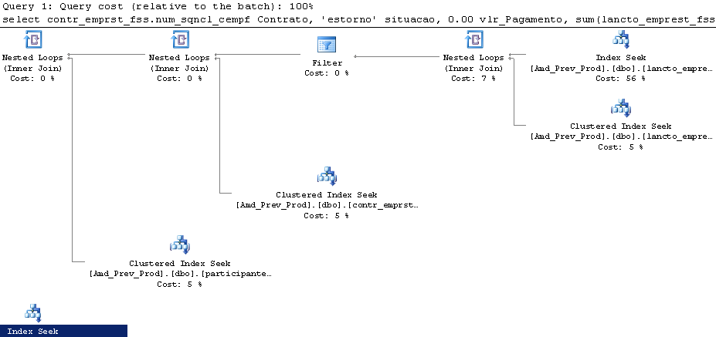

Table 'lancto_emprest_fss'. Scan count 274, logical reads 2665
Table 'empregado'. Scan count 0, logical reads 816, physical reads 7
Table 'participante_fss'. Scan count 0, logical reads 816, physical reads 13
Table 'contr_emprst_fss'. Scan count 1276, logical reads 9536

SQL Server Execution Times:
CPU time = 93 ms, elapsed time = 84 ms.

Modification:

FROM in ( 1, 2, 3, 4, 5, 6, 7, 8 ) TO between 1 and 8

FROM in ( 6 ) TO =6

select contr_emprst_fss.num_sqncl_cempf Contrato, 'quitado' situacao, sum(lancto_emprest_fss.vlr_pagto_lcemp) vlr_Pagamento, 0.00 vlr_estorno from empregado, participante_fss, contr_emprst_fss, lancto_emprest_fss where ( empregado.cod_emprs = participante_fss.cod_emprs ) and ( empregado.num_rgtro_emprg = participante_fss.num_rgtro_emprg ) and ( participante_fss.num_matr_partf = contr_emprst_fss.num_matr_partf ) and ( contr_emprst_fss.num_sqncl_cempf = lancto_emprest_fss.num_sqncl_cempf ) and ( contr_emprst_fss.cod_tpepf between 1 and 8 ) and ( contr_emprst_fss.cod_situa_cempf <> 'C' ) and ( contr_emprst_fss.dat_incl_cempf between {ts '2012-01-01 00:00:00.000'} and {ts '2012-01-31 00:00:00.000'}) and ( contr_emprst_fss.dat_quitc_cempf between {ts '2012-01-01 00:00:00.000'} and {ts '2012-01-31 00:00:00.000'}) and ( lancto_emprest_fss.cod_tipo_lcemp = 'Q') and ( 0 = 0 ) AND ( contr_emprst_fss.num_plbnf = 6 ) AND ( lancto_emprest_fss.cod_situa_lcemp = 'L') and ( lancto_emprest_fss.dat_pagto_lcemp between {ts '2012-01-01 00:00:00.000'} and {ts '2012-01-31 00:00:00.000'}) group by contr_emprst_fss.num_sqncl_cempf

UNION

select contr_emprst_fss.num_sqncl_cempf Contrato, 'outros' situacao, sum(lancto_emprest_fss.vlr_pagto_lcemp) vlr_Pagamento, 0.00 vlr_estorno from empregado, participante_fss, contr_emprst_fss, lancto_emprest_fss where ( empregado.cod_emprs = participante_fss.cod_emprs ) and ( empregado.num_rgtro_emprg = participante_fss.num_rgtro_emprg ) and ( participante_fss.num_matr_partf = contr_emprst_fss.num_matr_partf ) and ( contr_emprst_fss.num_sqncl_cempf = lancto_emprest_fss.num_sqncl_cempf ) and ( contr_emprst_fss.cod_tpepf between 1 and 8) and ( contr_emprst_fss.cod_situa_cempf <> 'C' ) and ( contr_emprst_fss.dat_incl_cempf between {ts '2012-01-01 00:00:00.000'} and {ts '2012-01-31 00:00:00.000'}) and ( lancto_emprest_fss.dat_pagto_lcemp between {ts '2012-01-01 00:00:00.000'} and {ts '2012-01-31 00:00:00.000'}) and ( lancto_emprest_fss.cod_tipo_lcemp not in ('C', 'Q', 'E')) and ( 0 = 0 ) AND ( contr_emprst_fss.num_plbnf = 6) AND ( lancto_emprest_fss.cod_situa_lcemp = 'L') group by contr_emprst_fss.num_sqncl_cempf

UNION

select contr_emprst_fss.num_sqncl_cempf Contrato, 'estorno' situacao, 0.00 vlr_Pagamento, sum(lancto_emprest_fss.vlr_pagto_lcemp) vlr_estorno from empregado, participante_fss, contr_emprst_fss, lancto_emprest_fss where ( empregado.cod_emprs = participante_fss.cod_emprs ) and ( empregado.num_rgtro_emprg = participante_fss.num_rgtro_emprg ) and ( participante_fss.num_matr_partf = contr_emprst_fss.num_matr_partf ) and ( contr_emprst_fss.num_sqncl_cempf = lancto_emprest_fss.num_sqncl_cempf ) and ( contr_emprst_fss.cod_tpepf between 1 and 8) and ( contr_emprst_fss.cod_situa_cempf <> 'C' ) and ( contr_emprst_fss.dat_incl_cempf between {ts '2012-01-01 00:00:00.000'} and {ts '2012-01-31 00:00:00.000'}) and ( lancto_emprest_fss.dat_pagto_lcemp between {ts '2012-01-01 00:00:00.000'} and {ts '2012-01-31 00:00:00.000'}) and ( lancto_emprest_fss.cod_tipo_lcemp = 'E') and ( 0 = 0 ) AND ( contr_emprst_fss.num_plbnf = 6) AND ( lancto_emprest_fss.cod_situa_lcemp = 'L') group by contr_emprst_fss.num_sqncl_cempf

Table 'lancto_emprest_fss'. Scan count 274, logical reads 2665
Table 'empregado'. Scan count 0, logical reads 816
Table 'participante_fss'. Scan count 0, logical reads 816
Table 'contr_emprst_fss'. Scan count 219, logical reads 6365

The scan count and logical reads on the table contr_emprest_fss has been dropped FROM 1276, 9536 TO 219, 6365

Now, I’m going to create a nonclustered index on the table contr_emprst_fss,
under the column(dat_quitc_cempf);

( contr_emprst_fss.dat_quitc_cempf between {ts '2012-01-01 00:00:00.000'} and {ts '2012-01-31 00:00:00.000'})

create nonclustered index ix_contr_emprst_fss_006 on contr_emprst_fss(dat_quitc_cempf)

Table 'lancto_emprest_fss'. Scan count 273, logical reads 1452
Table 'empregado'. Scan count 0, logical reads 81
Table 'participante_fss'. Scan count 0, logical reads 81
Table 'contr_emprst_fss'. Scan count 3, logical reads 6081

Again, the Scan count and logical reads had been dropped to 3,6081

Keepping……

drop index ix_contr_emprst_fss_006 on contr_emprst_fss

create nonclustered index ix_contr_emprst_fss_006 on contr_emprst_fss(dat_quitc_cempf)
include (num_sqncl_cempf,cod_tpepf,num_plbnf,num_matr_partf,cod_situa_cempf,dat_incl_cempf)

Table 'lancto_emprest_fss'. Scan count 273, logical reads 1452
Table 'empregado'. Scan count 0, logical reads 81
Table 'participante_fss'. Scan count 0, logical reads 81
Table 'contr_emprst_fss'. Scan count 2, logical reads 504

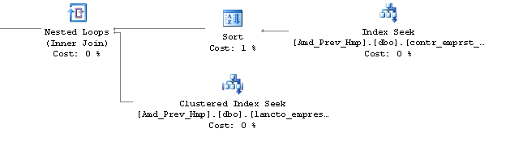

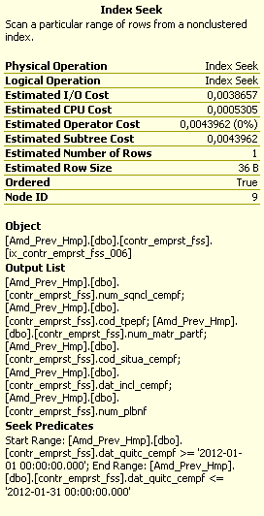

Respectfully

